**WELCOM PAGE**

**ADMIN CREDENTIALS REQUIRED**

**ADMINISTRATOR MENU**

**STUDENTS RELATED ACTIONS**

**BOOKS RELATED ACTIONS**

**ADDING NEW STUDENTS RECORD**

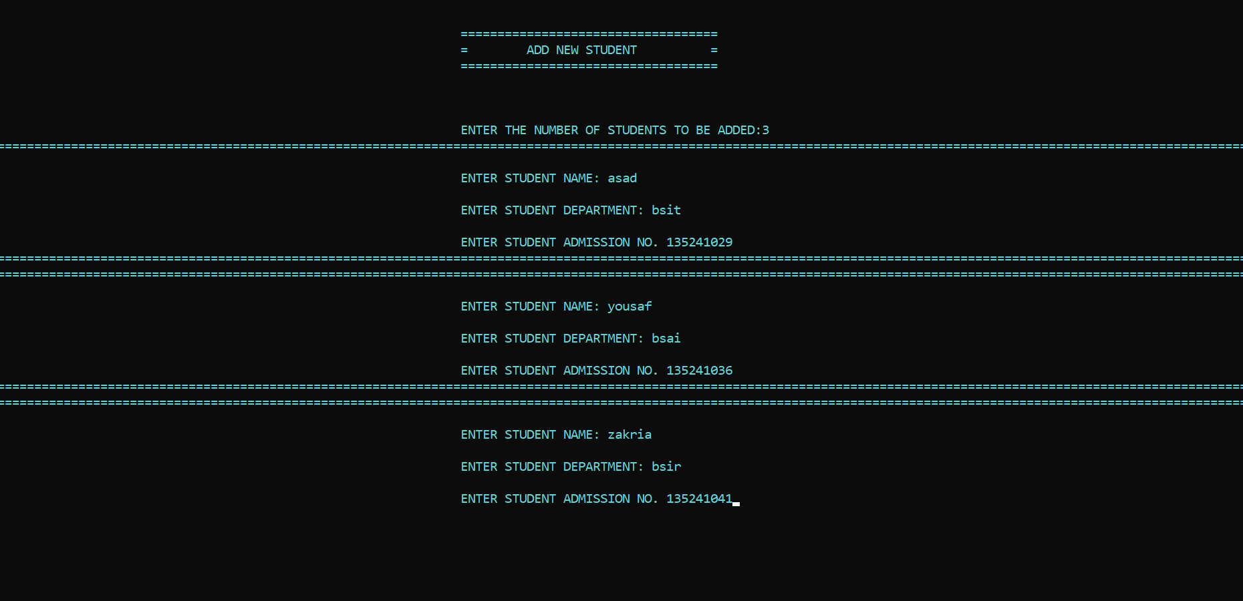

**ALL THE STUDENTS RECORD**

**ADDING NEW BOOKS RECORD**

**DISPLAYING ALL THE BOOKS RECORD**

**ISSUING A BOOK**

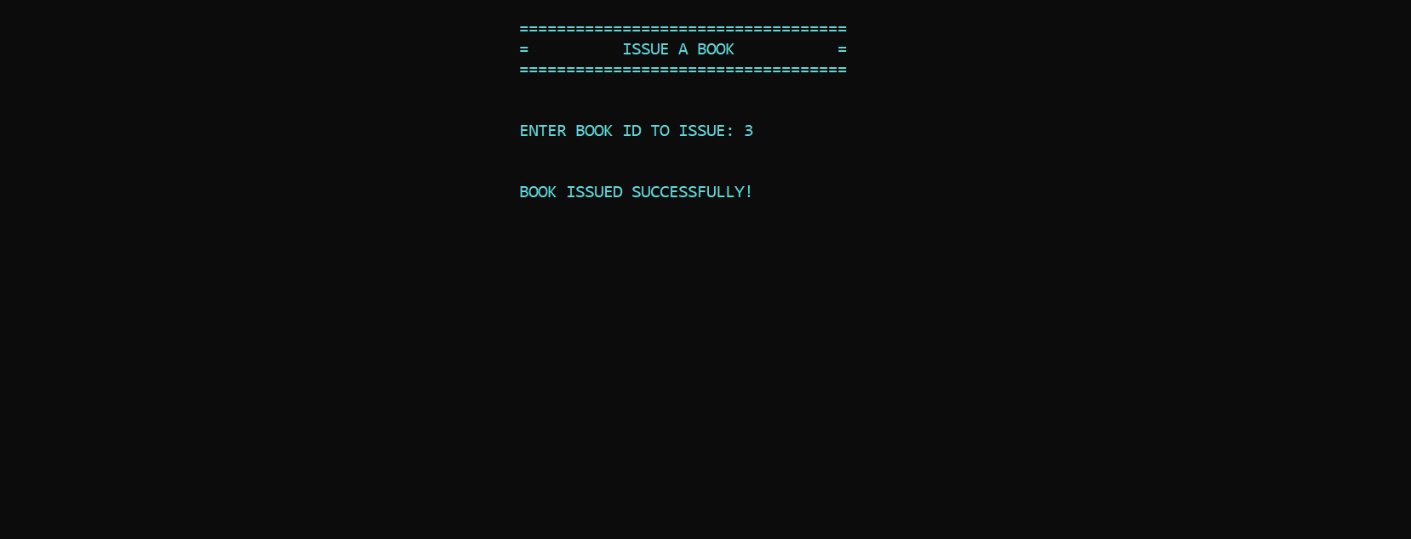

**RETURNING A BOOK**

**AVAILABLE BOOKS IN THE LIBRARY**

